

***Artificial Intelligence Fundamentals***

**Project of**

**COVID-19 Classification Detection System Based on Dense**

**Convolutional Network with SENet Module**

**Done by:**

***Amir Ali & Nader Tavana***

Computer Science and Information Systems

**16 June 2021**

**Responsibilities**

|  |  |
| --- | --- |
| **Name** | **Tasks** |
| ***Amir Ali*** | * System Architecture * Data Generation * Data Preprocessing * Model Architecture * Model Implementation * Result and Discussion |
| ***Nader Tavana*** | * Introduction * Related Work * Conclusion * Presentation |

**Table of Contents**

1. Abstract
2. Introduction
3. Some Existing Solution
4. Methodology
   1. Data Generation
   2. Data Preprocessing
   3. Model Architecture

**1. Abstract**

Coronavirus known as Covid-19 starts from Wuhan city of China and affects rapidly around all over the world. In March 2021, According to the Statistic of WHO approximately 120M cases reports and deaths are 2.66M which is extremely frightened. It has caused a devastating effect on both community health and the worldwide economy. This study proposes a computer vision method that can detect COVID-19 from chest X-ray images. For this purpose, we will use the Dense Convolutional Neural Network (DenseNet) as the basic building block module for the classification of COVID-19 Computed Tomography (CT) Chest Images.

**1. Introduction**

COVID-19 is a type of virus. It is called Novell because it is a new strain of the virus and its combination with the number 19 since it appeared in 2019. COVID-19 is a transferable virus caused by SARS-CoV-2. The most common symptoms of the virus are fever, dry cough, tiredness, difficulty breathing, and Chest Pain.

Coronavirus first case reports in November 2019 in Wuhan city of China and affected thousands of peoples. Then rapidly spread around all over the world. Now currently 2.66M cases Reports and Death around 2.6M.

The Coronavirus is first and foremost reach between people during close contact through sneezing, handshaking, eating, etc. The virus approaches the cell membrane which very dangerous for the human body. As it can infect people easily and can spread from person-to-person very spontaneously, the quick identification and isolation of the affected person is the very first step to fight against this virus. Polymerase chain reaction (PCR) is the primary method for detecting COVID-19 cases. It can detect SARS-CoV-2 RNA from respiratory specimens such as nasopharyngeal or oropharyngeal swabs [1]. Though this method is the most effective one, it is very time consuming and intensive lab work is required after the collection of the samples to get the result.

Another approach is the examination of chest radiography imaging (e.g., radiology or computed tomography (CT) imaging), which can be conducted faster but an expert analysis is needed to interpret the subtle differences. For removing this bottleneck, many AI-based systems have been proposed to detect COVID-19 from radiography images. Moreover, AI solutions are much faster than traditional methods where radiologists need to examine the images by hand. Some previous works used AI solutions with CT images to detect COVID19 [2] [3]. But CT scans are more costly and in most cases CT image dataset is not publicly available. On the other hand, X-rays are more widespread, quicker and cheaper alternative. Therefore, we choose chest X-ray images in our study. We used publicly available COVID dataset [5] to train a deep learning model which can efficiently detect COVID-19 from chest X-ray images.

In our work, we have used the Dense Convolutional Network (DenseNet) [4] of 121 layers as our model. DenseNet makes the training of deep learning models manageable by alleviating the vanishing gradient problem, increasing feature reuse, and decreasing parameter usage. It has attained state-of-the-art performance in several computer vision tasks. Moreover, DenseNet has been used successfully in disease prediction from radiology images.

**2. Some Existing Solution**

Computer vision [12] helps us building autonomous systems to perform tasks similar to the human visual system and, in some cases, better performance than human vision. One of the significant contributions of computer vision is in better diagnosing, treatment, and prediction of diseases using medical imaging data [13]. Deep neural network (DNN) has a great capability in the image classification task [14] and convolutional neural network (CNN, or ConvNet) [15] is one of the most popular classes of DNN. AlexNet [16], VGG [17], Inception [18], ResNet [19], DenseNet [6] are some of the popular convolutional networks.

AlexNet [16] architecture is composed of five convolutional layers, followed by three fully connected layers. Instead of the standard tanh or sigmoid function, it uses ReLU (Rectified Linear Unit) for the non-linear part after each convolutional and fully connected layer. ReLU is much faster in case of training than the sigmoid function. It also solved the problem of over-fitting by introducing the idea of a drop-out layer.

VGG16 and VGG19 architecture are from the VGG group. Instead of large kernel-sized filters used in AlexNet, VGG16 and VGG19 use multiple 3X3 kernel-sized filters consecutively. This multiple stacked smaller size kernel works better than AlexNet because it increases the depth of the network and provides the chance to learn more complex features at a low cost. VGG16 contains 16 weight layers where VGG19 has 19. In the VGG group, convolutional layers are followed by fully connected layers. Also, all the hidden layers are equipped with ReLU.

Inception is initially known as GoogleNet. Though VGG is a good model, it takes an extensive computational cost in terms of memory and time. Inception reduces the cost by introducing a bottleneck layer (1X1 convolutional filter). Also, it uses convolutions of different sizes like 5X5, 3X3, 1X1 to capture the details. It also reduces the total number of parameters by replacing the fully-connected layers with a global average pooling after the last convolutional layer.

ResNet is a deeper network than VGG16(with 16 layers) and VGG19(with 19 layers) but smaller because of the use of global average pooling instead of the fully-connected layers(like inception model). By adding some connections directly to the output skipping training from a few layers, it tries to handle the problem of vanishing gradient descent. This is called a residual network. That means with the help of this type we can train very deep networks. ResNet50 is from this group with 50 weight layers.

DenseNet architecture is designed in such a way that all the layers are directly connected ensuring maximum information flow in the network. Also unlike ResNet, here features are concatenated. This architecture requires less parameters and computation to get state-of-art performance.

Numerous works have been done in detecting COVID-19 from radiography images. Different model architectures have been used for accurate detection of the disease. COVIDNet [5] introduced a deep convolutional neural network design for detecting COVID-19 using the COVIDx dataset, which comprises 13,975 chest X-ray images. COVID-Net network architecture uses projection-expansion-projectionextension (PEPX) design pattern (Figure 1). They utilized a human-machine collaborative design strategy. This strategy

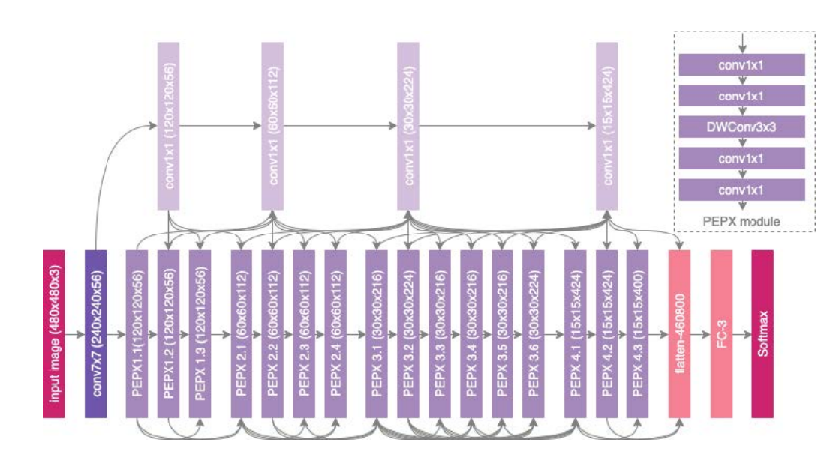

**Figure 1:** COVID-Net [5] Architecture

Combines human-driven principled network design prototyping and machine-driven design exploration. In the final detection, they have used 4 class classifications: Normal, Bacterial, NonCOVID-19 Viral, and COVID-19 Viral

**Table 1:** Sensitivity (Recall) of COVID-Net [5]

|  |  |  |  |
| --- | --- | --- | --- |
| Normal | Bacterial | Non-Covid Viral | COVID Viral |
| 73.9 | 93.1 | 81.9 | 100 |

**Table 2:** Precision of COVID-Net [5]

|  |  |  |  |
| --- | --- | --- | --- |
| Normal | Bacterial | Non-Covid Viral | COVID Viral |
| 95.1 | 87.1 | 67.0 | 80.0 |

From Table 1and 2, it is clear that the COVID-Net is very good at detecting COVID-19 infection as sensitivity (recall) is 100%. A small portion of radiology images is misclassified as COVID-19. But for other classes, both the sensitivity (recall) and positive predictive value (precision) rate can be improved. So, there is a lot more to contribute to properly detect the COVID-19 from other respiratory infections as they are all very similar. The COVID-Net model has achieved a test accuracy of 93.3%.

COVNet [4] has differentiated COVID-19 from Community-Acquired Pneumonia (CAP) from chest CT images. The dataset was collected from 6 hospitals and is not publicly accessible. COVNet is a 3D deep learning framework (can extract both 3D global and 2D local representative features) and contains a ResNet50 [19] as the backbone. They have used U-net [20] to segment the lung region from the chest radiology images. The training dataset contains 1165 images of COVID-19, 1560 from CAP, and 1193 of non-pneumonia CT scans. They have trained their model with both CAP and non-pneumonia CT images to check the robustness of how efficiently their model can differentiate between COVID-19 and other similar lung diseases. Table 3 gives us an overview of the performance of their model, which seems very promising but not for public use.

Transfer learning is a technique where the knowledge gained from solving a specific problem is transferred to solve a different but similar problem.

Table 3: Sensitivity (Recall) & Specificity of COVNet [4]

|  |  |  |  |
| --- | --- | --- | --- |
|  | COVID-19 | CAP | Non-Pneumonia |
| Sensitivity | 90 | 87 | 94 |
| Specificity | 96 | 92 | 96 |

Transfer learning can provide great results in detecting various irregularities in small medical image datasets. Paper [1] adopted a transfer learning technique to evaluate the performance of some state-of-the-art convolutional neural network architectures. They used two different datasets in this experiment. Table 4 presents a summary of their datasets.

Table 4: Datasets used in paper [17]

|  |  |  |  |
| --- | --- | --- | --- |
|  | COVID-19 | Pneumonia | Normal |
| Dataset 1 | 224 | 700 | 504 |
| Dataset 2 | 224 | 714 | 504 |

The author evaluated five CNN models which are VGG19 [2], MobileNet v2 [3], Inception [4], Xception [5], and Inception ResNet v2 [4]. Among these models, MobileNet v2 [3] provided the best results in terms of specificity in their particular datasets. Table V presents the results of MobileNet v2 [3] on Dataset 2. The results from Table 5 are promising. But this experiment was performed on a particular small dataset. For practical medical use, especially in a pandemic like COVID-19, this model needs to perform well on large datasets as well.

Dark Covid Net is another deep learning model proposed in paper [6]. The author used Darknet-19 [7] model as their base model and designed Dark Covid Net architecture. Dark Covid Net has 17 convolutional layers in contrast to the 19 convolutional layers in Darknet-19.

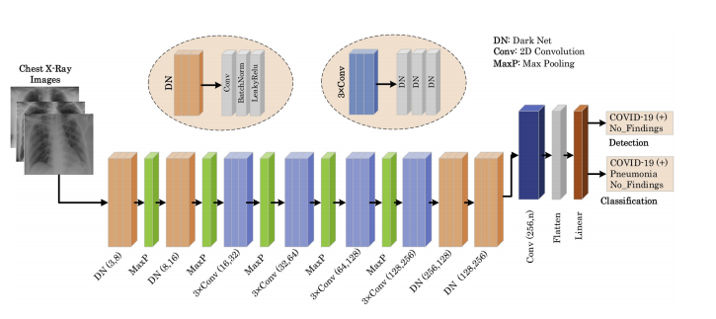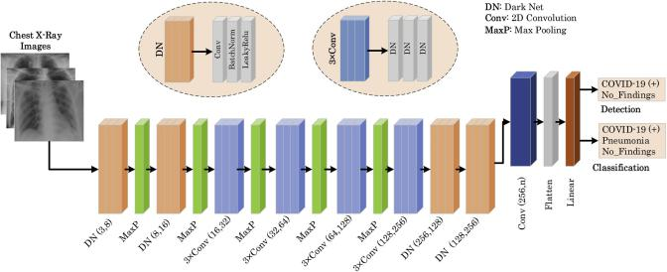

Figure 2: Dark Covid Net Architecture

Dark Covid Net used a dataset of 1125 chest X-ray images, which comprises 125 images that were diagnosed with COVID-19, 500 images with pneumonia, and 500 images were

Table 5: Results of MobileNet v2 on Dataset 2

|  |  |  |  |
| --- | --- | --- | --- |
| Accuracy | | Sensitivity | Specificity |
| 2 Class | 3 Class |
| 0.96 | 0.94 | 0.98 | 0.96 |

Normal. The result of their experiment is presented in Table 6.

Table 6: Experiment results of Dark Covid Net [11]

|  |  |  |  |  |  |
| --- | --- | --- | --- | --- | --- |
| Classification | Sensitivity | Specificity | Precision | F-1 Score | Accuracy |
| 2 class | 0.95 | 0.95 | 0.98 | 0.96 | 0.98 |
| 3 class | 0.85 | 0.92 | 0.89 | 0.87 | 0.87 |

From the table, it is clear that Dark Covid Net is very good at detecting COVID-19 for 2-class classification. But there are rooms for improvements for 3-class classification. This method needs more contribution to detect COVID-19 from other respiratory infections as well.

**4. Methodology**

As our dataset contains a small amount of COVID-19 radiography images, learning a deep learning model can be very problematic in this scenario because deep learning models require a large number of data for training from scratch. Transfer learning can used as a viable solution to this problem. In transfer learning algorithms, information learned in one domain is utilized to perform another task in other domains. For example, it a common practice to initialize deep learning models with weights learned by the ImageNet dataset [8] in computer vision domains. ImageNet is an enormous dataset containing 3.2 million images from different sources. The main advantage of such transfer learning algorithms is that pretrained models on dataset like ImageNet have already learned different features of different images. Later, these learned features can be utilized for any other domain-specific tasks by fine-tuning the pretrained model on the dataset of that domain. However, if the dataset used for pretraining is similar to the dataset of a specific task, it is expected that the pretraining process will have more relevant and useful features for that task. From this intuition, we utilized the CheXNet model [7] trained on chest X-ray images for pretraining instead of using AlexNet, VGG, inception or ResNet which are pretrained on ImageNet(with 1000 categories of images but with no chest X-ray images). The CheXNet model is basically the DenseNet-121 model, which was trained on the ChestRadiology-14 dataset [9] containing 112,120 chest radiology images from 30,805 unique patients to detect 14 different diseases from radiography images. As the ChexNet was trained on a huge dataset of radiography images, it is expected that the ChexNet has learned various features relevant to the radiography images. To utilize those learned features related to the radiography image, we used transfer learning from CheXNet by initializing our model by the weights of CheXNet. We used DenseNet-121 [6] as a deep learning model for feature extraction because this model has several advantages over other deep learning models for the image domain, which is explained in subsection 3(Model architecture).

The complete workflow proposed method is shown schematically in Figure 3. First, we load the pretrained DenseNet-121 model with the CheXNet model for feature extraction. Then we remove the last layer of the CheXNet model and replace it with a classifier specific to our task. For 3-class classification (COVID-19, Pneumonia, and Normal), our classifier is a fully connected layer with three neurons. For 2-class classification (COVID-19 and non-COVID-19), it is a fully connected layer with three neurons. Then we train our model (COVID-DenseNet) with the radiography images of COVIDx dataset [5] containing 13,800 radiography images of 13,725 unique patients. In the testing phase, this trained COVID-DenseNet model is efficiently used to predict the radiography image class. Finally, a gradient-based localization algorithm (Grad-Cam) [10] is used to identify the significant image regions that contribute to the prediction decisions.

**4.1 Data Generation**

Radiology images of COVID-19 infected patients are rare. We used COVIDx dataset assembled by [5]. They combined open source databases with chest radiology or CT images from [6], [7], [8]. We only used X-ray images to train our model and no CT scan images were used. The total number of COVID-19 infected Chest images are only 238. This number is extremely small compared to the number of radiology images available for pneumonia infected and healthy persons, which are 6045 and 8851 respectively. So the data is highly skewed because of the scarcity of images of COVID-19 patients. To deal with this unbalanced dataset, we augmented only the COVID-19 images in the training set. The following Table 4 shows the distribution of the dataset before and after augmentation.

**Table 6:** Class Distribution

|  |  |  |  |
| --- | --- | --- | --- |
| Class | Normal | Pneumonia | Covid-19 |
| No | 8851 | 6045 | 238 |
| Yes | 8851 | 6045 | 11416 |

The train-test split ratio is fixed at 0.9. We also stratified the train, validation, and test split so that the proportion is maintained in each set. We augmented the training data in six different methods. These are width shift, height shift, horizontal flip, rotation, brightness change, and zoom in or zoom out. We created 9 different images randomly for each category. So each COVID-19 radiology image in the training set has a total of 54 augmentations. For validating the result, the dataset was prepared for 10-fold cross-validation keeping the proportions of the class labels the same for each fold. We maintained augmentation leakage by creating an indexing system so that the augmentation of images in one fold does not fall in another one. We also maintained an index for patient ids’ so that no two folds have images of the same patient. Each patient a has variable number of images. So dividing the patients randomly among 10-folds would create an imbalance in terms of the number of images in each fold. So we had to maximize both the number of patients and images for each fold at the same time. We thus reduced the correlation between train and test images.

The COVID-19 dataset is currently growing. We created a new data injection method to add new images to our dataset.

This method also performs all the balancing acts to reduce the correlation of images between each fold.

**4.2 Preprocessing**

We used minimal preprocessing of the dataset before it is fed to our model. The only preprocessing was resizing every image to a similar dimension. We used images of height 224 pixels, width 224 pixels, and the number of channel 3 (224*224*3). Minimal preprocessing makes our inference process faster, so when testing, we can generate the model’s output (prediction and heatmap) in real-time.

**4.3. Model Architecture**

Our model is comprised of two parts, feature extractor, and classifier. For the feature extractor, we used Densenet-121 [6], and for the classifier, we used a fully connected layer with softmax activation function.

The main building block of DenseNet-121 is DenseBlock [6]. These Dense Blocks consist of Convolution Layers. In general, CNN architectures are hierarchical, so feature maps of (l − 1)th layer are input to the lth layer. But in DenseNet, feature-maps off all preceding layers are concatenated and used as input for any particular layer. Also, it’s own featuremaps are used as inputs for all subsequent layers. So, for lth layer, features maps of all preceding layers X0, X1, ..., Xl −1 are concatenated and used as it’s input.

Xl = H1 ([X0, X1, ..., Xl − 1]) (1)

Here Hl represents the lth layer, Xl is the output of the lth layer, and [X0, X1, ..., Xl − 1] represents the concatenation operation.

This special design improves information flow through the network and alleviates vanishing gradient problem. Moreover, DenseNet enhances feature reuse and parameter efficiency and provides each layer the collective knowledge of the network. Another important reason for choosing DenseNet as our architecture is that dense connection has a regularization effect, and it reduces over-fitting on training with smaller data sets [6], which is our case.

DenseNet-121 has four dense blocks and a transition layer between every two dense blocks (Figure 4). Each dense block consists of several convolution layers, and each transition layer consists of batch normalization, a convolution, and an average pooling layer. To increase nonlinearity ReLU activation function is used in DenseNet, which can be described as:

ReLU(x) = (x x > 0 (2)

0 x ≤ 0

In our model, the final layer of the Dense-121 is a global average pooling layer that generates the features from the input image. These features are used by the classifier to make the final prediction. For the classifier, we used a fully connected layer, followed by a softmax activation function. For 3-class classification, we used a fully connected layer of three units, and for 2-class classification, we used a fully connected layer of two units. The softmax activation normalizes the output of the fully connected layer and generates a probability distribution over the predicted output classes. The equation of the softmax function can be written as follows:

σ(zi) = (3)

Here, z is the input vector of the softmax function, zi values are the components of the input vector, and K is the number of classes.

**References**

[1] The Novel Coronavirus Pneumonia Emergency Response Epidemiology Team. Vital surveillances: The epidemiological characteristics of an outbreak of 2019 novel coronavirus diseases (covid-19) — china, 2020, February 2020.

[2] Wang. Detection of sars-cov-2 in different types of clinical specimens. JAMA, 2020.

[3] Ophir Gozes, Maayan Frid-Adar, Hayit Greenspan, Patrick D Browning, Huangqi Zhang, Wenbin Ji, Adam Bernheim, and Eliot Siegel. Rapid ai development cycle for the coronavirus (covid-19) pandemic: Initial results for automated detection & patient monitoring using deep learning ct image analysis. arXiv preprint arXiv:2003.05037, 2020.

[4] Lin Li, Lixin Qin, Zeguo Xu, Youbing Yin, Xin Wang, Bin Kong, Junjie Bai, Yi Lu, Zhenghan Fang, Qi Song, Kunlin Cao, Daliang Liu, Guisheng Wang, Qizhong Xu, Xisheng Fang, Shiqin Zhang, Juan Xia, and Jun Xia. Artificial intelligence distinguishes covid-19 from community acquired pneumonia on chest ct. Radiology, 296:200905, 03 2020.

[5] Linda Wang and Alexander Wong. Covid-net: A tailored deep convolu-tional neural network design for detection of covid-19 cases from chest radiography images. 03 2020.

[6] Gao Huang, Zhuang Liu, Laurens van der Maaten, and Kilian Wein-berger. Densely connected convolutional networks. 07 2017.

[7] Pranav Rajpurkar, Jeremy Irvin, Kaylie Zhu, Brandon Yang, Hershel Mehta, Tony Duan, Daisy Ding, Aarti Bagul, Curtis Langlotz, Katie Shpanskaya, et al. Chexnet: Radiologist-level pneumonia detection on chest x-rays with deep learning. arXiv preprint arXiv:1711.05225, 2017.

[8] Joseph Paul Cohen, Paul Bertin, and Vincent Frappier. Chester: A web delivered locally computed chest x-ray disease prediction system, 2019.

[9] X Wang, Y Peng, L Lu, Z Lu, M Bagheri, and RM Summers. Hospital-scale chest x-ray database and benchmarks on weakly-supervised clas-sification and localization of common thorax diseases. In IEEE CVPR, 2017.

[10] Ramprasaath R Selvaraju, Michael Cogswell, Abhishek Das, Ramakr-ishna Vedantam, Devi Parikh, and Dhruv Batra. Grad-cam: Visual explanations from deep networks via gradient-based localization. In Proceedings of the IEEE international conference on computer vision, pages 618–626, 2017.

[11] r